Lesson 5 Demo 21: Set up a Backup Schedule

This section will guide you to:

* Set up a backup schedule

**Step 1:** Set up a backup schedule for the swarm cluster

* Use the following command on the manager node to stop the Docker daemon:

*sudo service docker stop*

**

* Use the following command to create a backup by compressing the swarm folder in a tar file:

*sudo tar -czvf swarm.backup.tar var/lib/docker/swarm/*

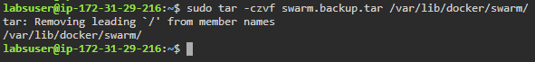

* Use the following commands to restore the backup in case of an emergency:

*sudo service docker stop*

*sudo rm -Rf /var/lib/docker/swarm*

*sudo tar -zxvf swarm.backup.tar -C /var/lib/docker*

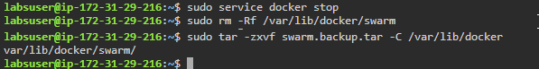

* Use the following commands to create a new configuration using the existing */var/lib/docker/swarm* directory:

*sudo service docker start*

*sudo docker swarm init --force-new-cluster*

